A000-Afr-Ghana-Koma-Ancester Grave Marker-Head-Terracotta-500-1300 CE

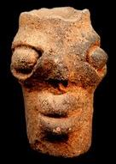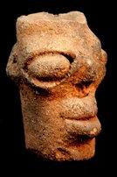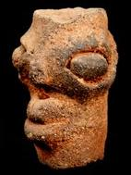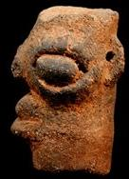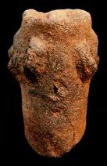

Figs. 1-5. Afr-Ghana-Koma-Ancester Grave Marker-Head-Terracotta-500-1300 CE

**Case No.: 6**

**Accession No.**

**Formal Label:**

**Display Description:**

The figurines were discovered during archaeological fieldwork directed by Professor Ben Kankpeyeng (University of Ghana) working with Professor Tim Insoll (University of Manchester) and the Ghana Museums and Monuments Board (GMMB). The Koma figurines have been dated to between approximately 500 and 1300 CE.  This corresponds broadly-speaking to the early to mid-Medieval Period in Britain. We don’t know a great deal about how the figurines were used but it would appear that they were used in special ceremonies and rituals in which the sprits of the ancestors were invoked. In the course of these ceremonies the figurines were deliberately broken. The fragments are often found in mounds, possibly because they were felt to have residual power and had to be disposed of carefully

**LC Classification:**

**Date or Time Horizon:** 500-1300 CE

**Geographical Area:**

**Map:**

**GPS coordinates:**

**Cultural Affiliation:**

**Medium: terracotta**

**Dimensions: H 2.55 in**

**Weight: 0.2 pounds**

**Condition:**

**Provenance:**

**Discussion:**

Excavated Funerary Figure from the Koma People, who live in Northern Ghana, West Africa. The discovery of the so-called "Koma Terracottas" is one the richest and most important archaeological finds in African art, and have become well-known in the circles of art dealers, collectors and lovers of African art. The figurines were first discovered during archaeological fieldwork directed by Professor Ben Kankpeyeng (University of Ghana) during the 1980s and have been dated to between approximately 500 and 1300 AD.

Komaland is located south of the Burkina Faso border in Northern Ghana, in the valleys between Sisilli and the Kulpawan rivers. The people of Komaland are mainly farmers, growing corn, millet, onions, tomatoes, and various types of nuts. Until 1985 very little was known about this mysterious culture. During the previous 20 years farmers had found terra cottas in the ground, but knew nothing of their history. Their value was soon recognized by scholars. In March and April of 1985 a permit was issued to excavate the Komaland site. Since then more information about this unique culture has filtered out. The present-day village is built around and on numerous archaeological sites. Many of the pieces found today and in the past 30 years were found in burial mounds; the mounds contained terracotta figures, domestic pottery, milling stones, pottery discs, iron ornaments, copper ornaments, iron implements and stone axes.

These artifacts were made by a previously little-understood people in what is known as Koma Land. The figurines are often fragmentary and depict stylized two-headed creatures, bird figures, animals, spiked heads, janus heads, and figurative forms. There is not a great deal of literature on how the figurines were used, but it has been suggested they were used in special ceremonies and rituals in which the spirits of the ancestors were invoked. It is possible that some had liquid offerings or libations poured into small channels burrowed into the tops of the figurines that exited through the nostrils or the mouth. Some have linked these channels with healing and medicine. In the course of ceremonies many figurines were deliberately broken. Later the fragments were buried in mounds, possibly because they were felt to have residual power and had to be disposed of carefully. When the Koma people began to farm the land where these pieces were found they were unearthed revealing the presence of an ancient culture.

**References:**

Kröger, F. and Saibu, B.B., 2010. *First notes on Koma culture: Life in a remote area of northern Ghana* (Vol. 13). LIT Verlag Münster.